**Môn:** Hệ quản trị Cơ sở dữ liệu

**Nhóm:** 7

**Tên thành viên:** Cao Nhật Hào

Bùi Đức Danh

Nguyễn Lê Thành Đạt

**Lớp:** 09CNTT3

**Lab 2**

**Bài 1: Quản lí bán hàng**

1. ***Code SQL***

create database QUANLYBANHANG

go

use QUANLYBANHANG

go

create table KHACHHANG(

MAKH CHAR(4) NOT NULL,

HOTEN VARCHAR(40) NOT NULL,

DCHI VARCHAR(50) NOT NULL,

SODT VARCHAR(20) NOT NULL,

NGSINH SMALLDATETIME NOT NULL,

NGDK SMALLDATETIME NOT NULL,

DOANHSO MONEY NOT NULL,

)

go

create table NHANVIEN(

MANV CHAR(4) NOT NULL,

HOTEN VARCHAR(40) NOT NULL,

SODT VARCHAR(20) NOT NULL,

NGVL SMALLDATETIME NOT NULL,

)

go

create table SANPHAM(

MASP CHAR(4) NOT NULL,

TENSP VARCHAR(40) NOT NULL,

DVT VARCHAR(20) NOT NULL,

NUOCSX VARCHAR(40) NOT NULL,

GIA MONEY NOT NULL

)

go

create table HOADON(

SOHD INT NOT NULL,

NGHD SMALLDATETIME NOT NULL,

MAKH CHAR(4) NOT NULL,

MANV CHAR(4) NOT NULL,

TRIGIA MONEY NOT NULL,

)

go

create table CTHD(

SOHD INT NOT NULL,

MASP CHAR(4) NOT NULL,

SL INT NOT NULL,

)

go

alter table KHACHHANG

add

constraint pk_KHACHHANG primary key(MAKH)

alter table NHANVIEN

add

constraint pk_NHANVIEN primary key(MANV)

alter table SANPHAM

add

constraint pk_SANPHAM primary key(MASP)

alter table HOADON

add

constraint pk_HOADON primary key(SOHD)

alter table CTHD

add

constraint pk_CTHD primary key(SOHD, MASP)

alter table HOADON

add

constraint fk_HOADON_MAKH

foreign key(MAKH) references KHACHHANG(MAKH)

on delete cascade

alter table HOADON

add

constraint fk_HOADON_MANV

foreign key(MANV) references NHANVIEN(MANV)

on delete cascade

alter table CTHD

add

constraint fk_CTHD_MASP

foreign key(MASP) references SANPHAM(MASP)

on delete cascade

alter table CTHD

add

constraint fk_CTHD_SOHD

foreign key(SOHD) references HOADON(SOHD)

on delete cascade

alter table NHANVIEN

add

constraint fk_NHANVIEN_HOTEN

foreign key(HOTEN) references KHACHHANG(HOTEN)

on delete cascade

1. ***Relationship***

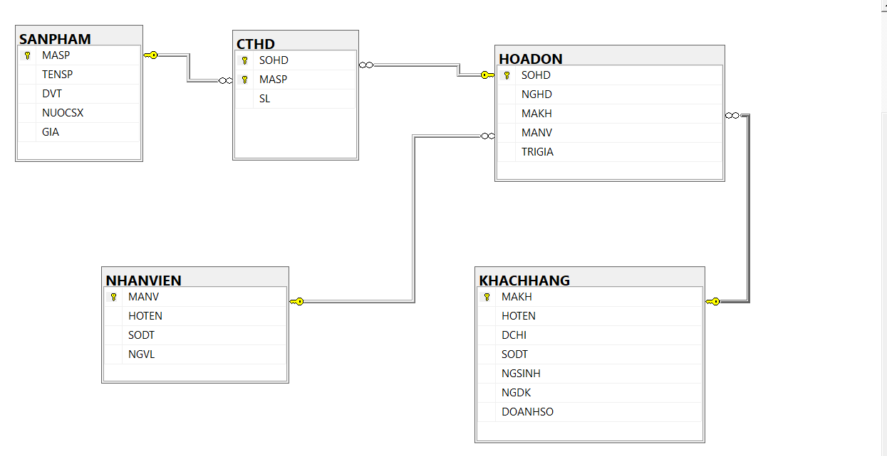

**Bài 2: Quản lí giáo vụ**

1. ***Code SQL***

Create database QLGV

GO

USE QLGV

CREATE TABLE KHOA(

MAKHOA VARCHAR(4) NOT NULL,

TENKHOA VARCHAR(40) NOT NULL,

NGTLAP SMALLDATETIME NOT NULL,

TRGKHOA CHAR(4) NOT NULL,

)

GO

CREATE TABLE MONHOC(

MAMH VARCHAR(10) NOT NULL,

TENMH VARCHAR(40) NOT NULL,

TCLT TINYINT NOT NULL,

TCTH TINYINT NOT NULL,

MAKHOA VARCHAR(4) NOT NULL,

)

GO

CREATE TABLE DIEUKIEN(

MAMH VARCHAR(10) NOT NULL,

MAMH_TRUOC VARCHAR(10) NOT NULL,

)

GO

CREATE TABLE GIAOVIEN(

MAGV CHAR(4) NOT NULL,

HOTEN VARCHAR(40) NOT NULL,

HOCVI VARCHAR(10) NOT NULL,

HOCHAM VARCHAR(10) NOT NULL,

GIOITINH VARCHAR(3) NOT NULL,

NGSING SMALLDATETIME NOT NULL,

NGVL SMALLDATETIME NOT NULL,

HESO NUMERIC(4,2) NOT NULL,

MUCLUONG MONEY NOT NULL,

MAKHOA VARCHAR(4) NOT NULL,

)

GO

CREATE TABLE LOP(

MALOP CHAR(3) NOT NULL,

TENLOP VARCHAR(40) NOT NULL,

TRGLOP CHAR(5) NOT NULL,

SISO TINYINT NOT NULL,

MAGVCN CHAR(4) NOT NULL,

)

GO

CREATE TABLE HOCVIEN(

MAHV CHAR(5) NOT NULL,

HO VARCHAR(40) NOT NULL,

TEN VARCHAR(10) NOT NULL,

NGSINH SMALLDATETIME NOT NULL,

GIOITINH VARCHAR(3) NOT NULL,

NOISINH VARCHAR(40) NOT NULL,

MALOP CHAR(3) NOT NULL,

)

GO

CREATE TABLE GIANGDAY(

MALOP CHAR(3) NOT NULL,

MAMH VARCHAR(10) NOT NULL,

MAGV CHAR(4) NOT NULL,

HOCKY TINYINT NOT NULL,

NAM SMALLINT NOT NULL,

TUNGAY SMALLDATETIME NOT NULL,

DENNGAY SMALLDATETIME NOT NULL,

)

GO

CREATE TABLE KETQUATHI(

MAHV CHAR(5) NOT NULL,

MAMH VARCHAR(10) NOT NULL,

LANTHI TINYINT NOT NULL,

NGTHI SMALLDATETIME NOT NULL,

DIEM NUMERIC(4,2) NOT NULL,

KQUA VARCHAR(10) NOT NULL,

)

GO

ALTER TABLE KHOA

ADD

CONSTRAINT PK_KHOA PRIMARY KEY (MAKHOA)

GO

ALTER TABLE MONHOC

ADD

CONSTRAINT PK_MONHOC PRIMARY KEY (MAMH)

GO

ALTER TABLE GIAOVIEN

ADD

CONSTRAINT PK_GIAOVIEN PRIMARY KEY (MAGV)

GO

ALTER TABLE LOP

ADD

CONSTRAINT PK_LOP PRIMARY KEY (MALOP)

GO

ALTER TABLE HOCVIEN

ADD

CONSTRAINT PK_HOCVIEN PRIMARY KEY (MAHV)

GO

ALTER TABLE KHOA

ADD

CONSTRAINT PK_KHOA_TRGKHOA FOREIGN KEY (TRGKHOA) REFERENCES GIAOVIEN(MAGV)

GO

ALTER TABLE LOP

ADD

CONSTRAINT PK_LOP_TRGLOP FOREIGN KEY (TRGLOP) REFERENCES HOCVIEN(MAHV)

GO

**Bài: QUẢN LÍ ĐỀ ÁN**

1. ***Code SQL***

Create database QuanLyDoAn

GO

USE QuanLyDoAn

CREATE TABLE NhanVien(

HONV nvarchar(15) NOT NULL,

TENLOT nvarchar(15) NOT NULL,

TENNV nvarchar(15) NOT NULL,

MANV nvarchar(9) NOT NULL,

NGSINH datetime NOT NULL,

DCHI nvarchar(30) NOT NULL,

PHAI nvarchar(3) NOT NULL,

LUONG float NOT NULL,

MA_NQL nvarchar(9) NULL,

PHG int NULL,

)

GO

CREATE TABLE PhongBan(

TENPHG nvarchar(15) NOT NULL,

MAPHG int NOT NULL,

TRPHG nvarchar(9) NULL,

NG_NHANCHUC date NOT NULL,

)

GO

CREATE TABLE CongViec(

MADA int NOT NULL,

STT int NOT NULL,

TEN_CONG_VIEC nvarchar(50) NOT NULL,

)

GO

CREATE TABLE DeAn(

TENDEAN nvarchar(15) NOT NULL,

MADA int NOT NULL,

DDIEM_DA nvarchar(15) NOT NULL,

PHONG int NULL,

)

GO

CREATE TABLE DiaDiem_Phg(

MAPHG int NOT NULL,

DIADIEM nvarchar(15) NOT NULL,

)

GO

CREATE TABLE PhanCong(

MA_NVIEN nvarchar(9) NOT NULL,

MADA int NOT NULL,

STT int NOT NULL,

THOIGIAN float NOT NULL,

)

GO

CREATE TABLE ThanNhan(

MA_NVIEN nvarchar(9) NOT NULL,

TENTN nvarchar(15) NOT NULL,

PHAI nvarchar(3) NOT NULL,

NGSINH date NOT NULL,

QUANHE nvarchar(15) NOT NULL,

)

GO

ALTER TABLE DeAn

ADD

CONSTRAINT PK_DeAn PRIMARY KEY (MADA)

GO

ALTER TABLE NhanVien

ADD

CONSTRAINT PK_NhanVien PRIMARY KEY (MANV)

GO

ALTER TABLE PhongBan

ADD

CONSTRAINT PK_PhongBan PRIMARY KEY (MAPHG)

GO

ALTER TABLE DiaDiem_Phg

ADD

CONSTRAINT PK_DiaDiem_Phg PRIMARY KEY (MAPHG,DIADIEM)

GO

ALTER TABLE ThanNhan

ADD

CONSTRAINT PK_ThanNhan PRIMARY KEY (MA_NVIEN,TENTN)

GO

ALTER TABLE CongViec

ADD

CONSTRAINT PK_CongViec PRIMARY KEY (MADA,STT)

GO

ALTER TABLE PhanCong

ADD

CONSTRAINT PK_PhanCong PRIMARY KEY (MA_NVIEN,MADA,STT)

GO

ALTER TABLE DeAn

ADD

CONSTRAINT PK_DeAn_PHONG FOREIGN KEY (PHONG) REFERENCES PhongBan(MAPHG)

GO

ALTER TABLE DiaDiem_Phg

ADD

CONSTRAINT PK_DiaDiem_Phg_MAPHG FOREIGN KEY (MAPHG) REFERENCES PhongBan(MAPHG)

GO

ALTER TABLE NhanVien

ADD

CONSTRAINT PK_NhanVien_PHG FOREIGN KEY (PHG) REFERENCES PhongBan(MAPHG)

GO

ALTER TABLE ThanNhan

ADD

CONSTRAINT PK_ThanNhan_MA_NVIEN FOREIGN KEY (MA_NVIEN) REFERENCES NhanVien(MANV)

GO

ALTER TABLE PhanCong

ADD

CONSTRAINT PK_PhanCong_STT_MADA FOREIGN KEY (STT,MADA) REFERENCES CongViec(MADA,STT)

GO

ALTER TABLE CongViec

ADD

CONSTRAINT PK_CongViec_MADA FOREIGN KEY (MADA) REFERENCES DeAn(MADA)

GO

ALTER TABLE PhongBan

ADD

CONSTRAINT PK_PhongBan_TRPHG FOREIGN KEY (TRPHG) REFERENCES NhanVien(MANV)

GO

ALTER TABLE PhanCong

ADD

CONSTRAINT PK_PhanCong_MA_NVIEN FOREIGN KEY (MA_NVIEN) REFERENCES NhanVien(MANV)

GO

1. ***Sử dụng biến thực hiện các công việc***

SELECT HONV,TENLOT,TENNV,PHG

FROM NHANVIEN

WHERE PHG = 4

SELECT HONV,TENLOT,TENNV,LUONG

FROM NHANVIEN

WHERE LUONG > 30000

SELECT HONV,TENLOT,TENNV,PHG,LUONG

FROM NHANVIEN

WHERE LUONG > 25000 AND PHG = 4 OR LUONG > 30000 AND PHG = 5

SELECT HONV+ ' ' +TENLOT+ ' ' +TENNV as 'Họ Và Tên'

FROM NHANVIEN

WHERE DCHI like N'%TP HCM'

SELECT HONV+ ' ' +TENLOT+ ' ' +TENNV as 'Họ Và Tên'

FROM NHANVIEN

WHERE HONV like N'N%'

SELECT NGSINH,DCHI

FROM NHANVIEN

WHERE HONV = N'Đinh' and TENLOT=N'Bá' and TENNV=N'Tiên'

SELECT (HONV+ ' ' +TENLOT+ ' ' +TENNV) AS 'Nhân Viên Lương Cao Nhất'

FROM NHANVIEN

WHERE LUONG >=(SELECT MAX(LUONG) FROM NHANVIEN)

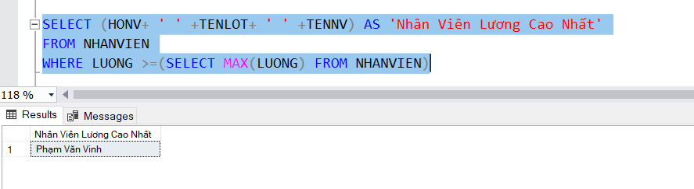

SELECT (HONV+ ' ' +TENLOT+ ' ' +TENNV) AS 'Họ Tên Nhân Viên Có Lương Trên Mức Lương Trung Bình Của Phòng "Nghiên cứu"'

FROM NHANVIEN

WHERE LUONG > (SELECT AVG(LUONG)

FROM NHANVIEN, PHONGBAN

WHERE PHG = MAPHG AND TENPHG = N'Nghiên cứu')

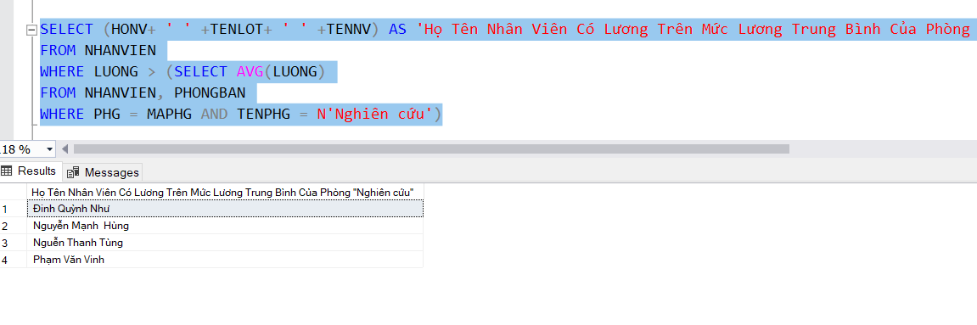

SELECT TENPHG, COUNT(MANV) AS N'Số lượng nhân viên'

FROM NHANVIEN, PHONGBAN

WHERE PHG = MAPHG GROUP BY TENPHG HAVING AVG(LUONG)>30000

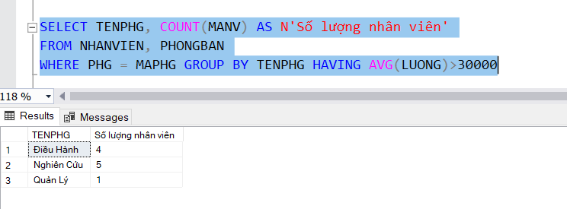

SELECT TENPHG, COUNT(PHONG) AS 'Số lượng đề án'

FROM PHONGBAN, DEAN

WHERE MAPHG = PHONG GROUP BY TENPHG

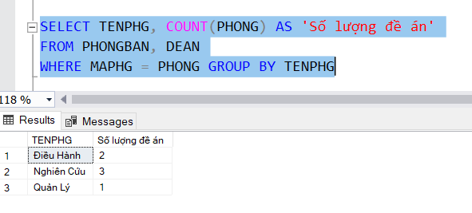

1. ***Relationship***

